Class Observations: Why and How to Observe Classes

Contents

Class Observations as a Springboard for Reflection 2

Your Class Observation Schedule during CATT 2

Signing Up for MOOCs (Massive Open Online Courses) 3

Signing up for Udacity 4

Signing up for Khan Academy 10

Signing up for FutureLearn 14

Signing up for Coursera 21

Signing up for EdX 26

Finding Lectures Online 29

# Class Observations as a Springboard for Reflection

Observing classes in your field can allow you to get ideas for teaching, reflect on your past teaching practices and motivations, and help you make conscious plans for future teaching.

You can focus your observations and reflections on a wide variety of areas, such as:

* Student-teacher rapport
* Student involvement in the classroom
* Use of technology in the classroom
* Use of English materials
* Lecture style and techniques
* Group work
* Homework vs. classwork
* Learner autonomy and responsibility
* Use of powerpoints, handouts, textbooks, etc. to structure lectures
* Role of homework and assessment in the course
* Writing on the board
* Time management
* Student note-taking practices
* Training in academic skills
* Many more…

# Your Class Observation Schedule during CATT

You will observe classes in three ways during your CATT Program. Instructions on how to find these three types of courses in your field or a related one are below. In general, it is best to observe classes in your field, but you may choose to observe one or two classes outside of your field if you are curious about different approaches.

1. Signing Up for MOOCs: Join a MOOC and begin following at least one course in your field.
2. Finding Lectures Online: Choose some videos of classes to watch online.
3. Observe a course face-to-face at the University of Arizona.

# Signing Up for MOOCs (Massive Open Online Courses)

*Schedule: Join a MOOC and follow it throughout CATT. Ask instructors and colleagues if you experience difficulties with this. It will be helpful for you to reflect on your learning process for this kind of technology to empathize with students.*

MOOCs (Massive Open Online Courses) are online classes in a wide variety of fields that require registration, but are often free. At times, the course is free, but if you wish to have a certificate stating that you completed all requirements satisfactorily, you must pay for that. As instructors, they can be useful places to build vocabulary in your field in English, to seek alternative ways to explain concepts, or to get ideas about what kinds of materials to use and how to use them. You may also choose to suggest or require your students to enroll in courses related to yours.

Instructions for joining the following MOOCs are below:

* Udacity
* Khan Academy
* Future Learn
* Coursera
* EdX

## Signing up for Udacity

<https://www.udacity.com/>



Picture 1: Udacity home page

Udacity is a gathering of MOOCs, or Massive Open Online Courses. A MOOC is generally designed by a university or other organization, and available to anyone who has an interest in the topic. Some MOOCs offer the opportunity to take the course for credit or certification for an extra fee, but generally a MOOC does not charge for basic course materials like videos, handouts, discussion boards, and similar features. MOOCs are available on a wide variety of topics, so you will probably find one related to your field of interest.

Signing up for Udacity is straightforward. You supply your name, an email address, and choose a password.

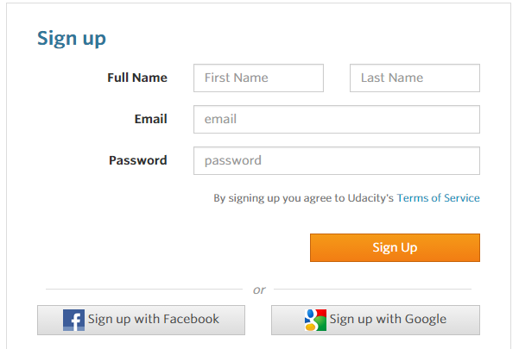

Picture 2: Signing up for Udacity

Your first step is to create an account. From the home page, then click on “Sign Up.” You will need to supply your name, an email address, and create a password. Then you will click the next “Sign Up” button.

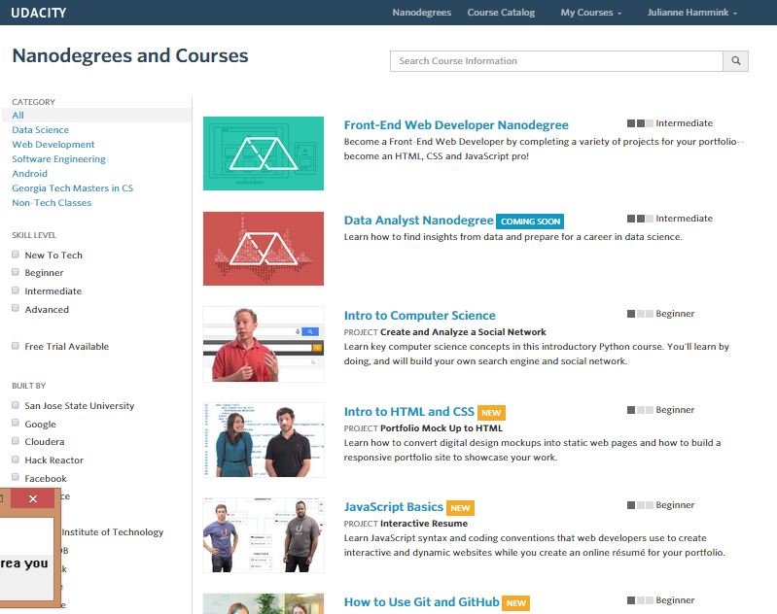

Picture 3: Browsing for courses

Next, you will be able to browse the list of courses. You may want to narrow down search results by choosing a subject area on the left–hand side of the screen. Once you click the title of a specific course, you will be taken to the home page for that course.

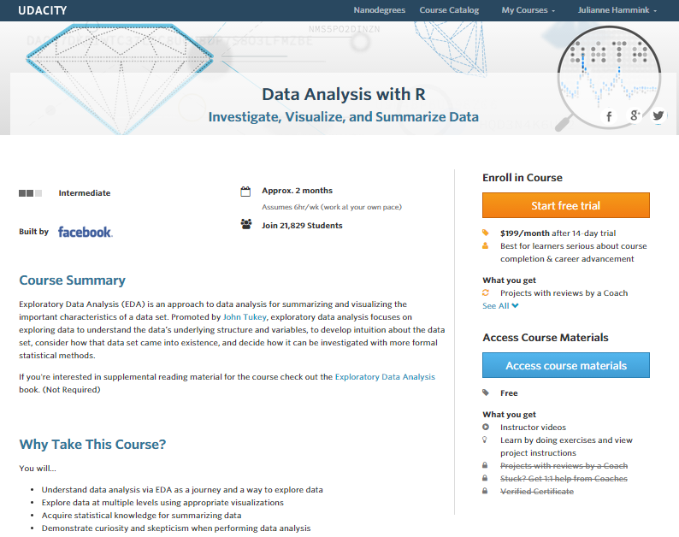

Picture 4: A typical course home page

From the course home page, you can join the course by clicking on the blue “Access Course Materials” button on the right-hand side of the screen. You do **not** need to choose the button that says “Start free trial.”

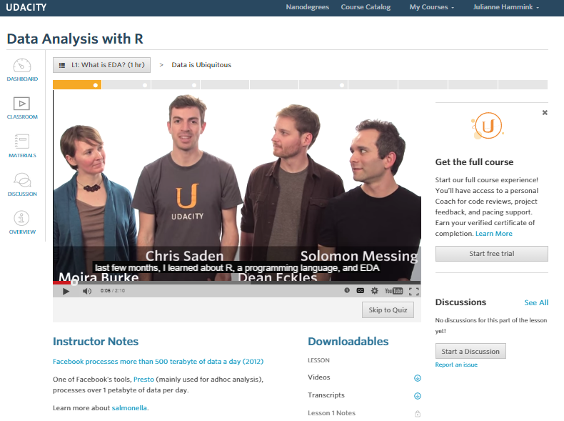

Picture 5: Course start page

To begin using course materials, select the “Dashboard” button.

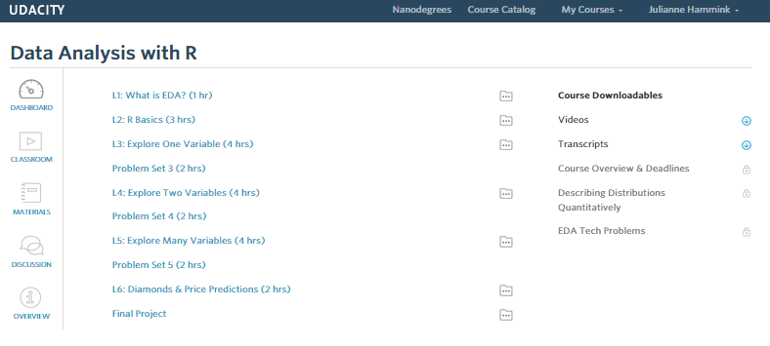

Picture 6: Course syllabus & materials

Depending upon the materials made available for the specific course, you may be able to view videos, read transcripts and notes, and/or participate in online discussions with other students.

## Signing up for Khan Academy

<https://www.khanacademy.org/>

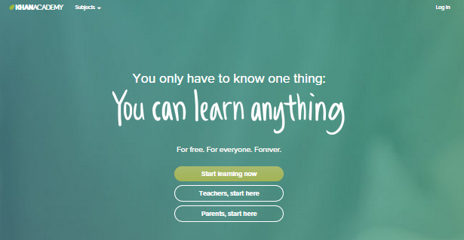

Figure 1: Khan Academy home page

Khan Academy is a gathering of MOOCs, or Massive Open Online Courses. A MOOC is generally designed by a university or other organization, and available to anyone who has an interest in the topic. Some MOOCs offer the opportunity to take the course for credit or certification for an extra fee, but generally a MOOC does not charge for basic course materials like videos, handouts, discussion boards, and similar features. MOOCs are available on a wide variety of topics, so you will probably find one related to your field of interest.

To begin, click on the home page button that says “Start learning now,” and then choose the “Sign up” button on the next page.

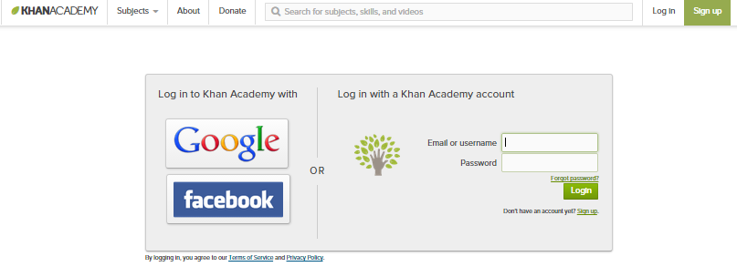

Figure 2: Choose "Sign Up" link

Signing up for Khan Academy is straightforward. You supply your name and an email address, and then choose a password.

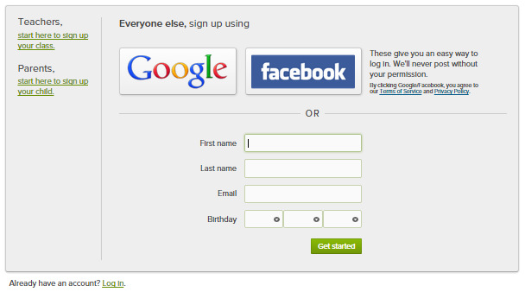

Figure 3: Signing up for an account on Khan Academy

If you’d like, you can choose an avatar- basically a small picture that identifies your profile.

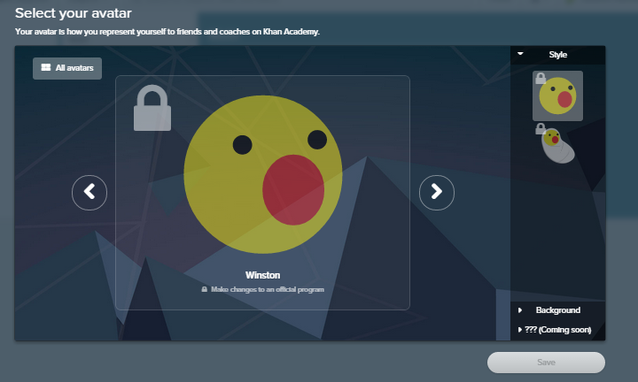

Figure 4: Choose an avatar

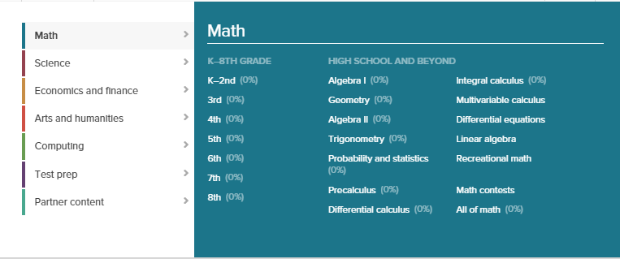

Figure 5: Browse and select courses

Khan Academy offers a wide variety of courses at various levels.

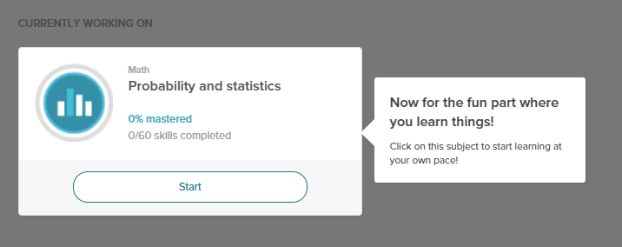

Figure 6: Sign up and begin a course

Once you have selected a course, you will be asked to “Start” the course.

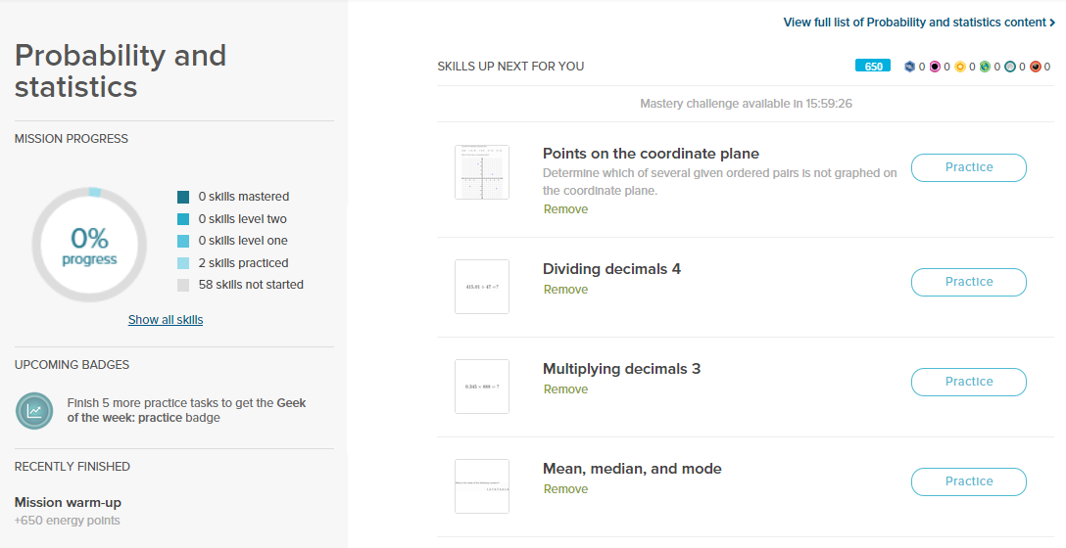

Figure 7: Accessing course content

After you have done a few warm-up exercises, you will be taken to the page with course content. This content will vary depending upon your performance on the warm-up exercises. From this point, you will be able to follow the course lessons in order.

## Signing up for FutureLearn

<https://www.futurelearn.com/>

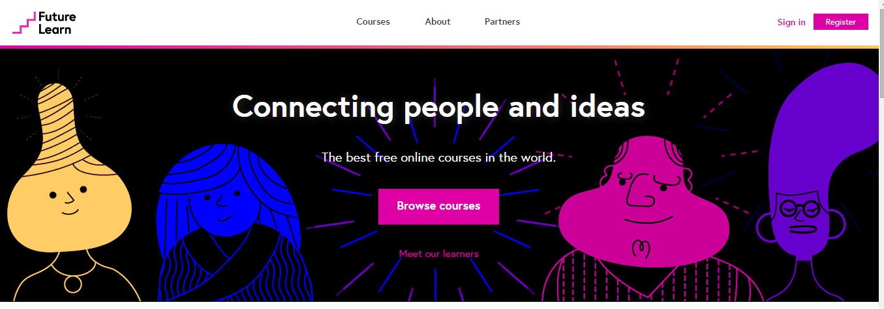

FutureLearn is a gathering of MOOCs, or Massive Open Online Courses. A MOOC is generally designed by a university or other organization, and available to anyone who has an interest in the topic. Some MOOCs offer the opportunity to take the course for credit or certification for an extra fee, but generally a MOOC does not charge for basic course materials like videos, handouts, discussion boards, and similar features. MOOCs are available on a wide variety of topics, so you will probably find one related to your field of interest.

To begin, click on the home page button that says “Register,” or you may choose “Browse Courses” first to identify a course that interests you.

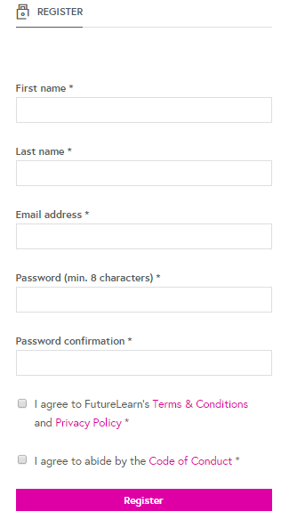

In order to register, you must first supply some basic information: your name, an e-mail address, and a password. You should also check the boxes next to the “Terms & Conditions” and the “Code of Conduct.” Then click “Register.”

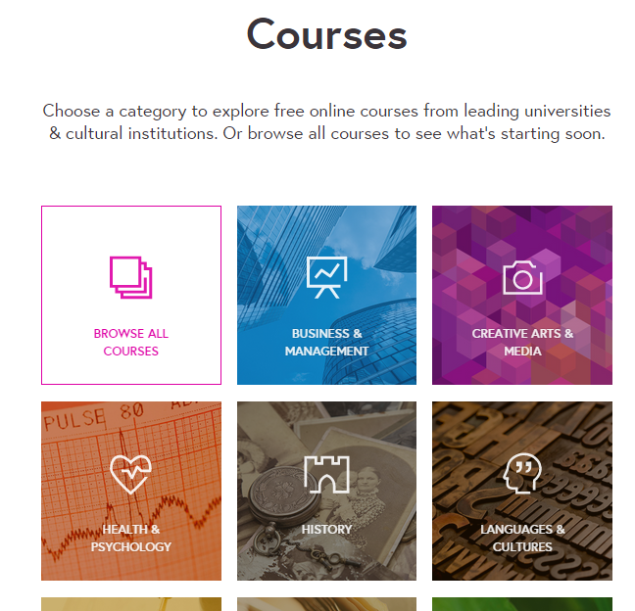

If you have not yet browsed the course offerings, you can do that now. You might want to narrow your search by subject area.

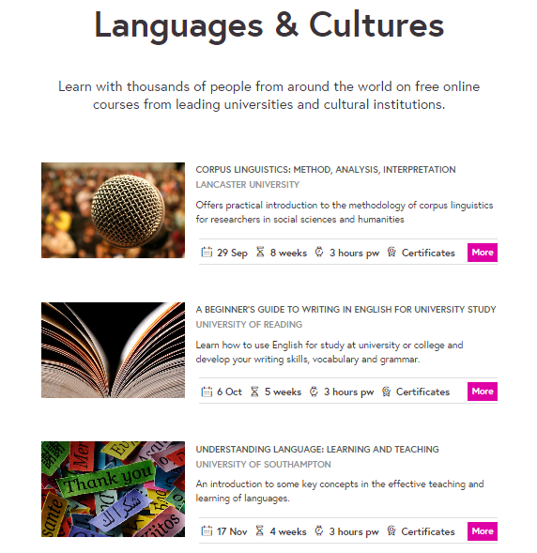

You will be shown a list of courses, as well as the beginning date, length of course, and approximate time commitment. You can click “More” to get additional information about a specific course.

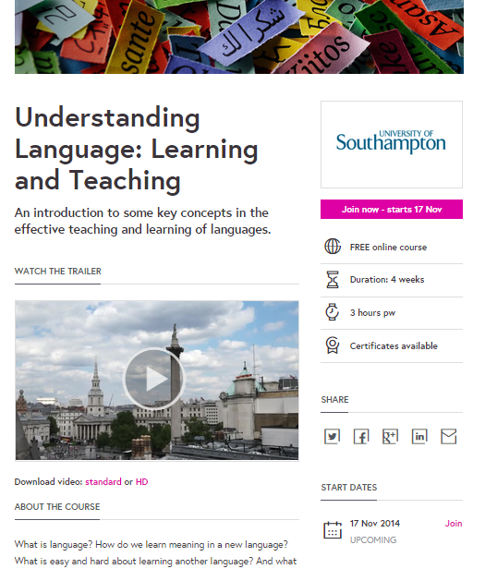

If you want to join the course after reading about it, click the “Join Now” button. Be sure to note the beginning date of the course.

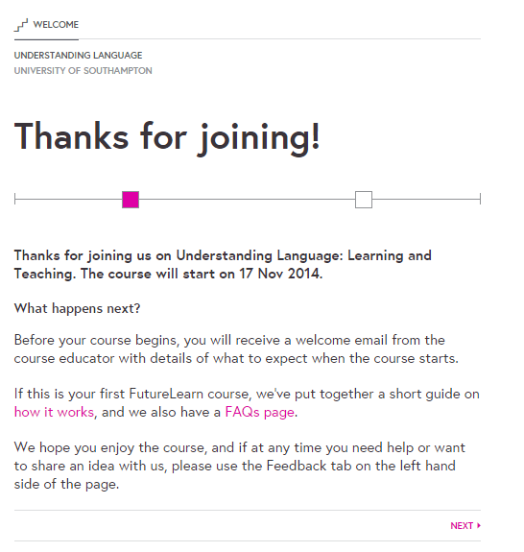

You have now officially registered for the course. If you are new to MOOCS, or FutureLearn specifically, you may want to read the FAQs and the “How it works” guide before the course begins.

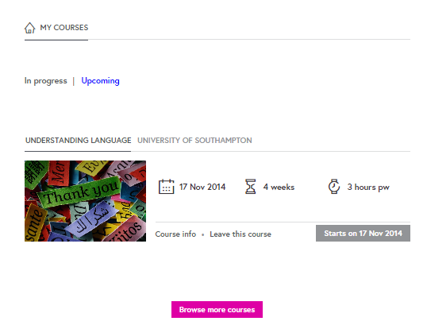

If you navigate to “My Courses,” you will be able to view a list of the courses for which you are registered. Once the course has begun, you will be able to access the offered materials, which may be videos, handouts, notes, and/or discussion forums. If you decide that you do not want to do a particular course, you can click on “Leave this course,” and you will be unenrolled.

## Signing up for Coursera

<https://www.coursera.org/>

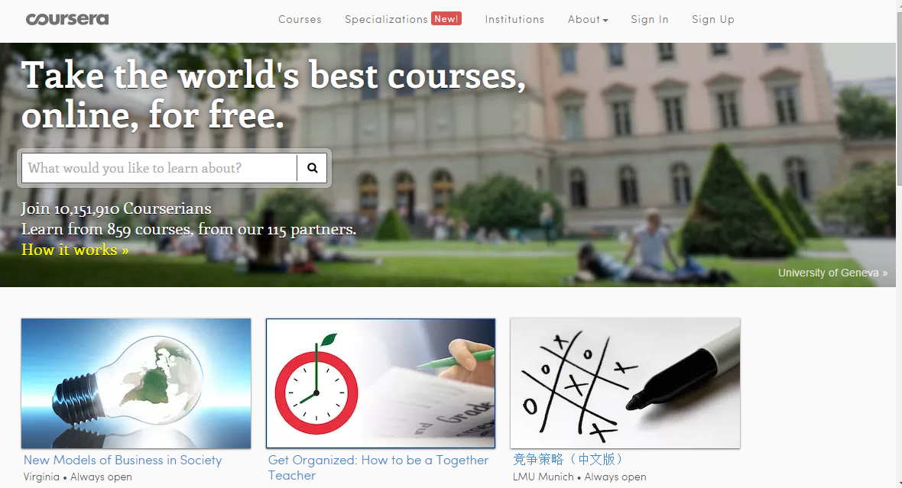

Picture 7 Coursera home page

Coursera is a gathering of MOOCs, or Massive Open Online Courses. A MOOC is generally designed by a university or other organization, and available to anyone who has an interest in the topic. Some MOOCs offer the opportunity to take the course for credit or certification for an extra fee, but generally a MOOC does not charge for basic course materials like videos, handouts, discussion boards, and similar features. MOOCs are available on a wide variety of topics, so you will probably find one related to your field of interest.

Signing up for Coursera is straightforward. You supply your name, an email address, and choose a password.

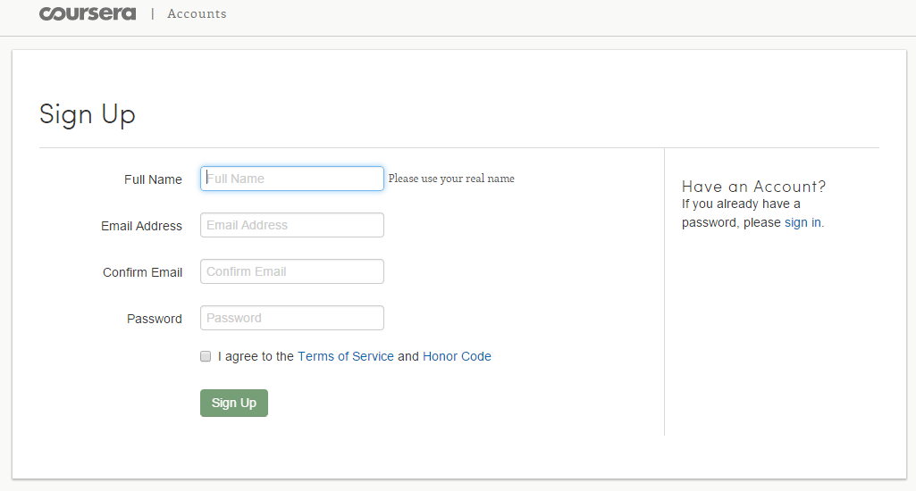

Picture 8 Sign up for a Coursera account

Once you have created a Coursera account, you will be able to browse course offerings.

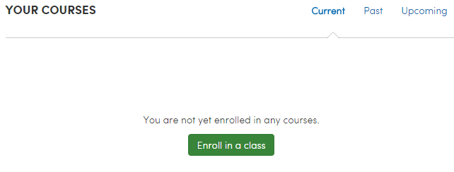

Picture 9 Find an interesting course

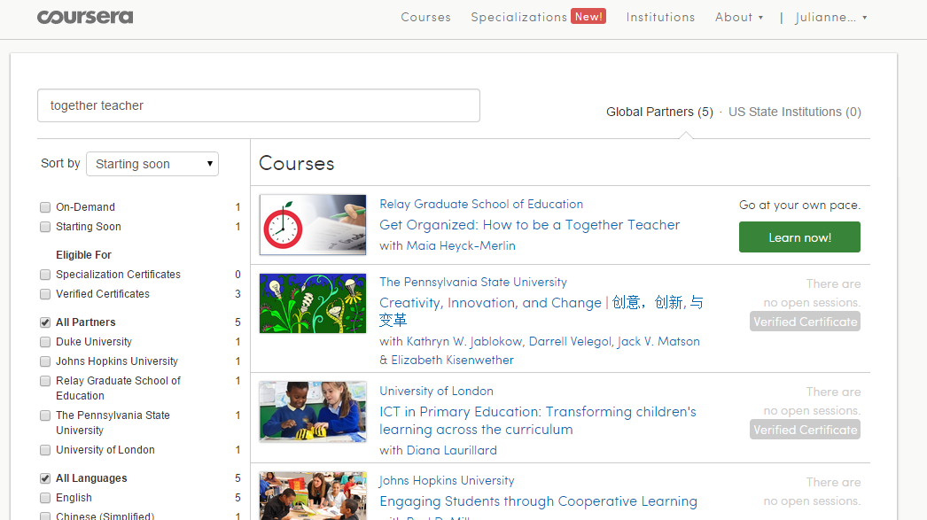

Picture 10 Choose from available courses in a variety of disciplines

By clicking the green “learn now!” button, you can learn more about the course that you have selected.

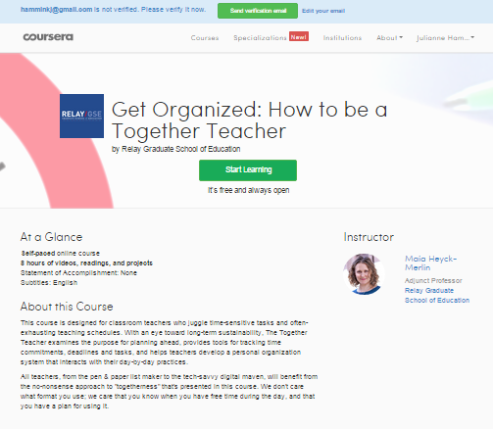

Picture 11 Learn more about a specific course

The home page for the course gives you a better idea of the type of activities and time commitment that the course will involve. The course above will take about 8 hours to complete, and involves readings, videos, and projects. This course is self-paced, although not all courses are. Click on the “Start Learning” button to enroll.

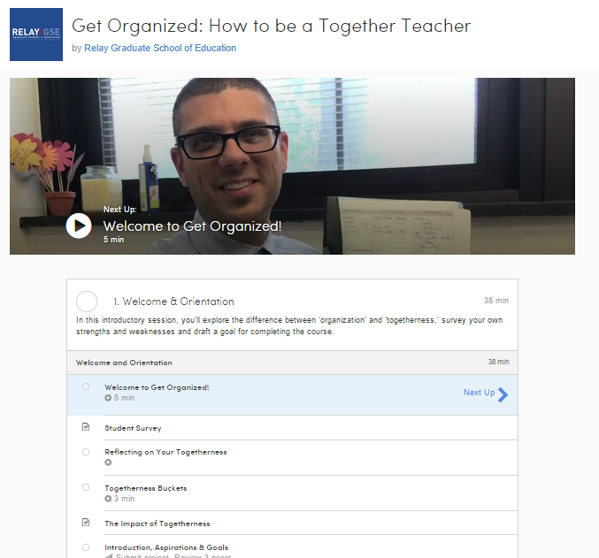

Picture 12 Begin the course by following the syllabus

A detailed syllabus is available after you enroll in the course. You will probably want to begin with the first module, titled “Welcome to Get Organized.” Happy learning!

## Signing up for EdX

Go to <https://www.edx.org/>

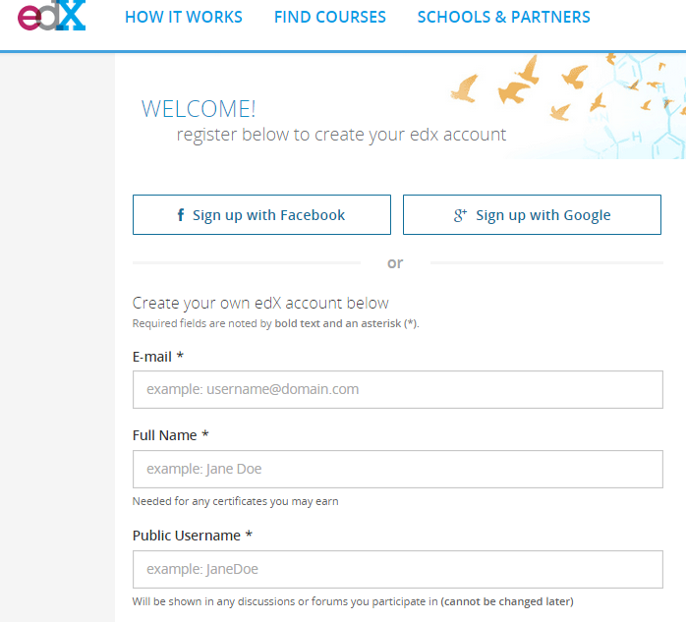

EdX is a gathering of MOOCs, or Massive Open Online Courses. A MOOC is generally designed by a university or other organization, and available to anyone who has an interest in the topic. Some MOOCs offer the opportunity to take the course for credit or certification for an extra fee, but generally a MOOC does not charge for basic course materials like videos, handouts, discussion boards, and similar features. MOOCs are available on a wide variety of topics, so you will probably find one related to your field of interest.

To begin, click on the “Register button on the home page. You will be asked to provide some basic information: your real name, a user name, and an e-mail address.

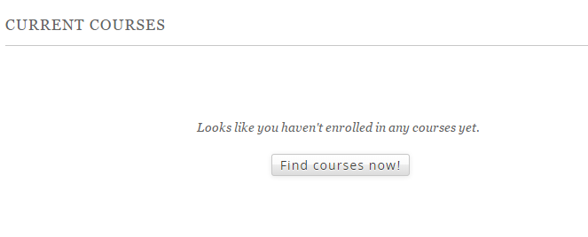

To find a course, you can click on the “Find Courses Now” button, and you will be taken to a list of all courses that are available.

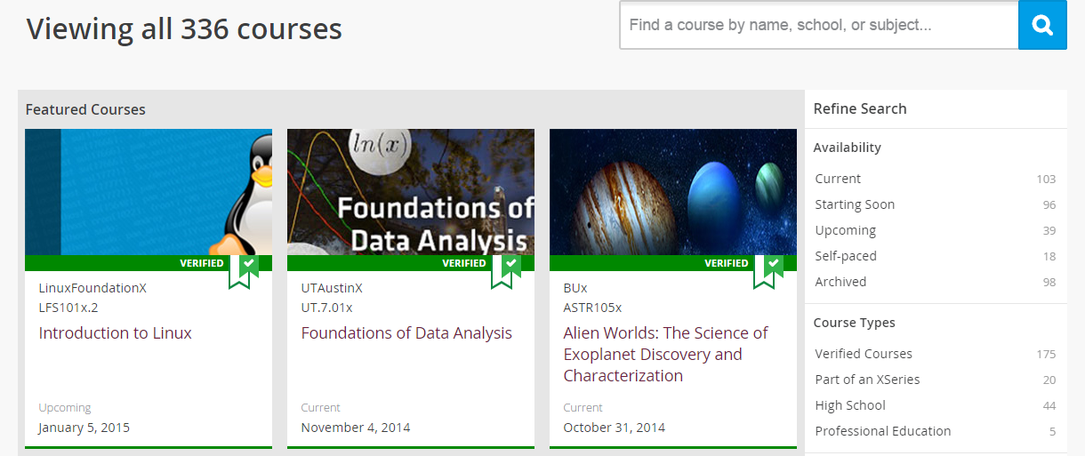

You may want to refine your search with the search tools on the right-hand side of the screen.

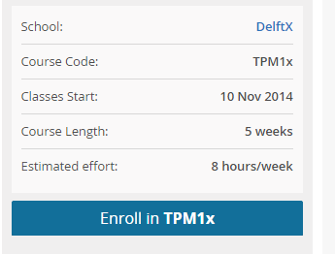

Once you have selected a course, you will be provided with some basic information about the course. Take note of the starting date for the course, as well as the length of the course and the approximate time commitment. To enroll, click on the “Enroll in…” button.

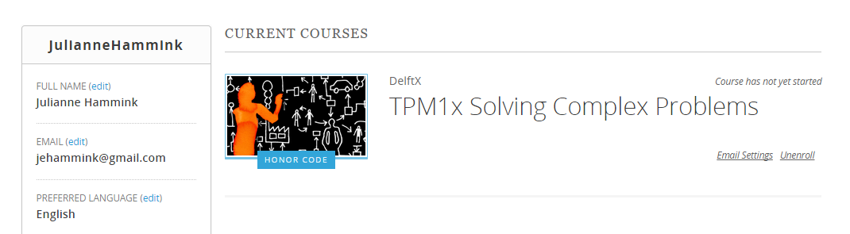

Finally, you will see the home page for the course in which you have enrolled. Once the course has begun, you will be able to access the course materials provided by the course designers.

# Finding Lectures Online

Similarly to MOOCs, observing online courses can give you more ideas for teaching and materials, help improve your English vocabulary in your field, and give you knowledge about where to direct your students when they could benefit from more exposure to your field or English in your field.

Links to specific courses:

* <http://ocw.mit.edu/courses/chemistry/5-111-principles-of-chemical-science-fall-2008/video-lectures/lecture-17/> Chemistry, MIT
* <https://www.youtube.com/watch?v=NNnIGh9g6fA> Human behavioral biology, Stanford
* <https://www.youtube.com/watch?v=B2wyclHrvzo&list=PL0D9C70597FD6410D> History, Columbia University
* <https://www.youtube.com/watch?v=vQBRdrFkrsw&list=UU4EY_qnSeAP1xGsh61eOoJA> Poetry, Yale University
* <https://www.youtube.com/playlist?list=PL8DA9DAD111EAAD28> Climate change and the law, UC Berkeley
* <http://freevideolectures.com/Course/2582/Introduction-to-Ethics> Introduction to ethics, University of Houston

Links to repositories of many more classes to choose from:

* <http://ocw.mit.edu/courses/> Lots more here
* [http://videolectures.net/Top/#](http://videolectures.net/Top/) Various sources